# School database

1. Description

We consider a school database that keep track of (student, subject, employee, dependent, class, grade)

The following requirement:

* For each student, the database maintains information on the student's (name, address, phone, social security number (ssn), year, birthdate, sex).
* For each subject maintain information (name, no, degree (min, max), year).
* For each employee maintain information (ssn , name , address ,sex , phone )
* There are three subclasses of employee are (manger , worker , teacher) the member of employee must be one of these sub classes
* For each teacher maintain information (hours per week)
* For each worker (specialization)
* For each class maintain (range, location, no).
* For each grade maintain information (type (fail-pass) , no)
* For each dependent maintain information (ssn , name ,phone , relationship)

There is a relationship between teacher and subject is called (teach) where (teacher must teach a subject and any subject must be taught by a teacher).

There is a relationship between student and class which is called (belongs to) where (any student must be a member in a class and any class must contains students).

There is a relation between student and subject which is called (study) where (each student must study a subject and each subject must be studied by students) where each student has current degree of the subject that he studies.

There is a relationship between teacher and class which is called (teach) where (class must be taught by a teacher).

There is a relationship between dependent and student which is called (has) where (each student must has a dependent and each dependent belongs to student at least).

There is a relationship between grade and student which is called (get) where (each student get a grade and each grade belongs to a student).

1. EER-Diagram

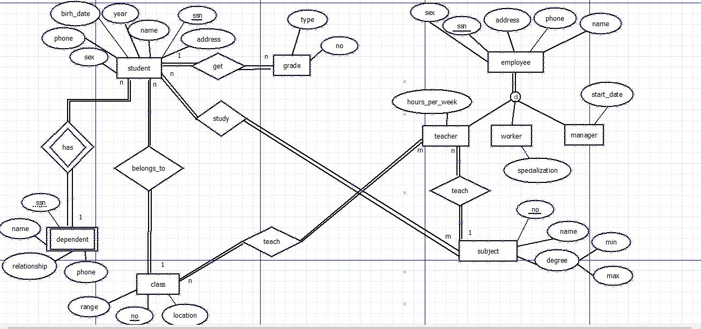

1. Relational Model

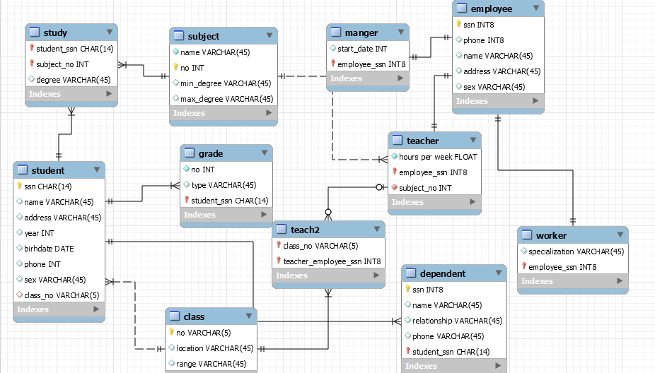

QUERIES:

1. Retrieve all information about each student

Select * from student;

1. Retrieve each student's name and his/her dependent's name

Select s.name, d.fname

From student s , dependent d

Where s.ssn=d.student_ssn;

1. Retrieve names of all students in class '3/2'

select s.name

from student s ,class c

where c.no=s.class_no and c.no='3/2';

1. Retrieve name of each teacher and the number of the class that he/she teaches in

select e.ename , c.no

from teacher t ,teach2 te , class c ,employee e

where t.employee_ssn=te.teacher_employee_ssn and c.no=te.class_no and e.ssn=t.employee_ssn;

1. Retrieve name of each teacher that teaches Arabic

select e.ssn, e.ename , sb.name

from teacher t , employee e , subject sb

where sb.no=t.subject_no and e.ssn=t.employee_ssn and sb.name='arabic' ;

1. Retrieve students who passed

select s.name , s.year ,g.type

from student s , grade g

where s.ssn=g.student_ssn and g.type='pass';

1. Retrieve name of each manager

select count(e.ename)

from employee e,manger m

where e.ssn=m.employee_ssn;

1. Retrieve name of each teacher and names of students he/she teaches to

select s.name as student , e.ename as teacher

from employee e , teacher t , student s , teach2 te,class c

where e.ssn=t.employee_ssn and t.employee_ssn=te.teacher_employee_ssn and c.no=te.class_no and s.class_no=c.no;

1. Retrieve number of students who passed in each class

select count(s.ssn), c.no

from student s , grade g , class c

where s.ssn=g.student_ssn and c.no=s.class_no and g.type='pass'

group by c.no;

1. Retrieve all employees that not teacher or manager and his/her specialization

select w.specialization , e.ename

from employee e, worker w

where e.ssn=w.employee_ssn;

1. Retrieve degree of each student in all subjects

select sum(st.degree) , s.name

from student s , study st , subject sb

where sb.no=st.subject_no and s.ssn=st.student_ssn

group by s.name;